Input:
using System;

namespace Abdullah_CP_Lab_08
{
class Program
{
static void Main(string[] args)
{
string[] days = { "Mon", "Tues", "wed", "Thurs"};
for (int j = 0; j<days.Length;j++)
{
Console.WriteLine("days{0} is {1}",j,days[j]);
}
}
}
}
Output:
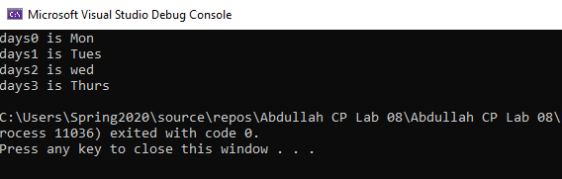
Input:
using System;

namespace Abdullah_CP_Lab_08
{
class Program
{
static void Main(string[] args)
{
Console.Write("Enter a positive integer");
int n = int.Parse(Console.ReadLine());
int[] array = new int[n];

Console.WriteLine("Enter the value of the array:");

for (int i =0;i<n;i++)
{
array[i] = int.Parse(Console.ReadLine());
}
bool symmetric = true;
for (int i = 0; i<array.Length/2;i++)
{
if (array[i]!= array[n-i-1])
{
symmetric = false;
break;
}
}
Console.WriteLine("Is symmetric? {0}", symmetric);
}
}
}

Output:
